**Operators Associativity and Precedence Assignment**

1. Use operator associativity, evaluate the folowing expressions and predict the output

a. x = 34 + 12/4 – 56

b. 12 + 3 - 4 / 2 < 3 + 1

c. (2 + (3 + 2) ) * 10

d. 34 + 12/4 – 45

**a . -19**

**b . FALSE**

**c. 70**

**d. -8**

2. Rewrite the following expressions with improved readability

a. age < 18 && height < 48 || age > 60 && height > 72

b. char name value

c. char $name

**a. (age<18 && height < 48 ) || (age>60 && height >72)**

**b. char name;**

**c. char name;**

3. Predict the value of a after each statement.

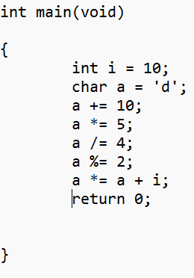

**I=10.**

**a= d, a=100**

**a=n a=110**

**a= nil a=550**

**a= nil a=137**

**a=nil a=1**

**a = nil a=11**

4. Consider a = 12, b = 3, predict the output of the following .

a. (a>100) && (b<10)

b. (a==4) && (b==2)

c. (a==11) && (a++)

**a. FALSE**

**b. FALSE**

**c. FALSE**

5. Consider a = 10, b = 11, predict the output of the following .

a. (a>10) || (b<10)

b. a || 12.12

c. a || b

d. !(a > 5)

**a. True**

**b. False**

**c. False**

**d. False**

6. Consider int age = 10, height = 45, year = 2000; Predict the output of the following.

a. (age < 12 && height < 48) || (age > 65 && height > 72)

b. (year % 4 == 0 && year % 100 != 0 ) || (year % 400 == 0);

**a. True**

**b.True**